# How to download a bootloader?

## Buy: standalone-avr-chip-programmer

<https://www.kiwi-electronics.nl/index.php?route=product/isearch&search=standalone-avr-chip-programmer&description=true>

or:

<https://nl.aliexpress.com/item/AVR-ISP-Shield-For-Arduino-Used-To-Download-Bootloader-Burning-for-Arduino/1916612038.html?spm=a2g0s.9042311.0.0.27424c4dVRA35V>

## Install Breadboard bootloader

Download from: <https://www.arduino.cc/en/Tutorial/ArduinoToBreadboard>

* Copy boards.txt to: Arduino\hardware\arduino\avr
* Copy bootloader to: Arduino\hardware\arduino\avr\bootloaders\Bread-board-atema328

## Download sketch for burning bootloaders

From: <https://github.com/adafruit/Standalone-Arduino-AVR-ISP-programmer>

## Upload sketch

* First modify Images.cpp (need internal clock):
  + Set the fuses before writing the to flash in the Images.cpp file:
    - {0x3F, 0xE2, 0xDA, 0x05}, // {lock, low, high, extended}
  + Copy the bootloader hex file to Images.cpp (but leave out line 123: :040000030000780081).
* select board configuration: "ATmega328 on a breadboard (8 MHz internal clock)"
* Upload sketch: Standalone-Arduino-AVR-ISP-programmer

## Download bootloader

Insert an Arduino on the programmer board and press the reset button on the programmer board to download the bootloader and setting the fuses.

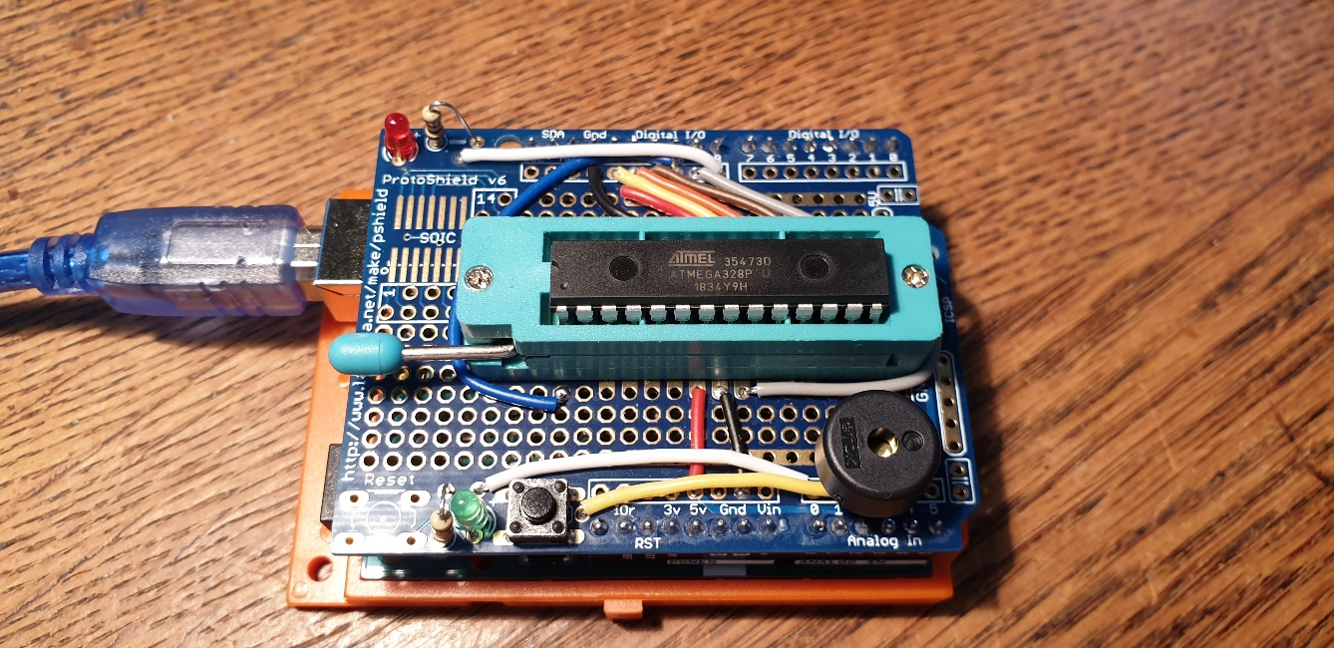

# How to download a sketch?

## Buy USB to serial device

AliExpress: FT232RL FTDI USB 3.3 V 5.5 V, USB naar TTL Seriële Adapter voor Arduino

See also: <http://auseparts.com.au/index.php?route=product/product&product_id=333>

## Connect to Arduino

RX on this board to the TX pin on your device  
TX on this board to the RX pin on your device  
GND on this board to GND on your device

5V on this board to 5V on your device

Connect DTR via a capacitor of 100 nF with the Reset pin of the Arduino.

Connect resistor of 10k from Reset pin to 5V.

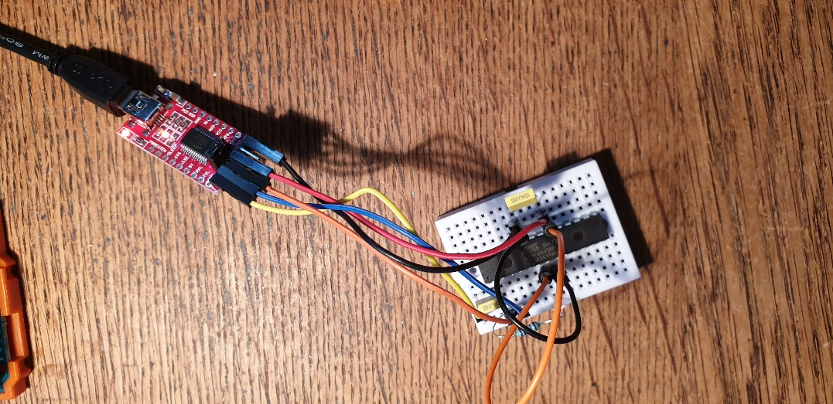

## Download sketch

* select board configuration: "ATmega328 on a breadboard (8 MHz internal clock)"
* Upload your sketch

